Enterprise Software Platforms

HW#6 - Tableau

**Team (Technocrats)**

Vijaylaxmi Nagurkar

Monica Dommaraju

Sruthi Chilukuri

Geethu padachery

**Getting started with Tableau Companion Workbook:** **3**

**Screenshots for completed lessons in the Companion Workbook** **3**

Sales Seasonality: 3

Crosstab: 4

Regional Sales and Profitability: 5

Sales by Category: 6

Customer Breakdown: 7

Sales Dashboard: 8

Table’s Profitability: 9

# 

# 

# 

# Getting started with Tableau Companion Workbook:

Downloaded Tableau Desktop and recreated the views as mentioned in the Companion Workbook.

# Screenshots for completed lessons in the Companion Workbook

## Sales Seasonality:

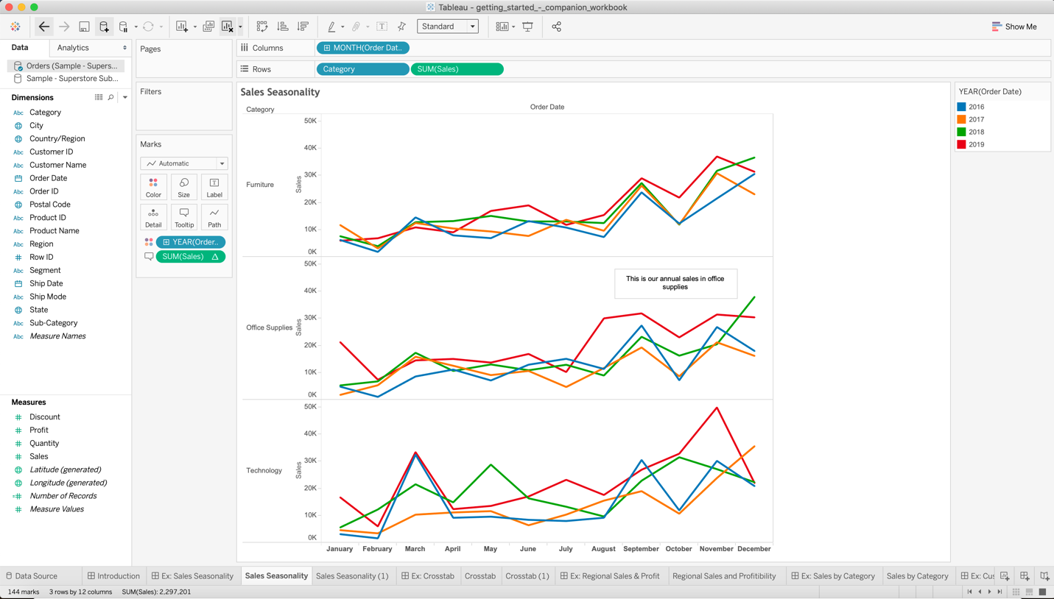

## Crosstab:

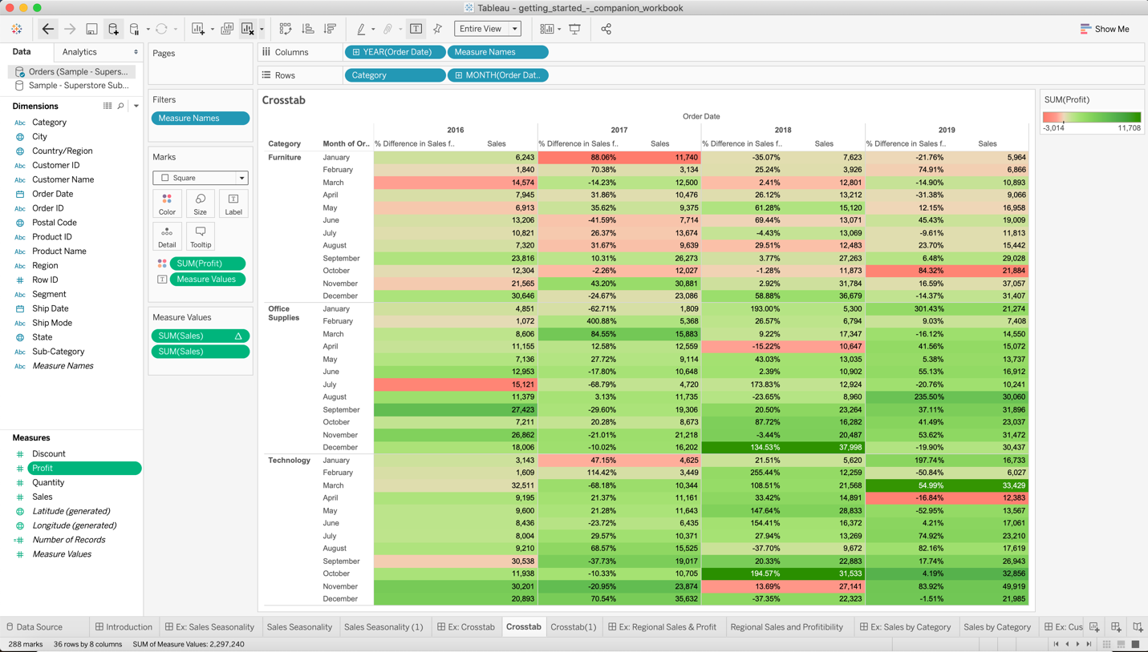

## Regional Sales and Profitability:

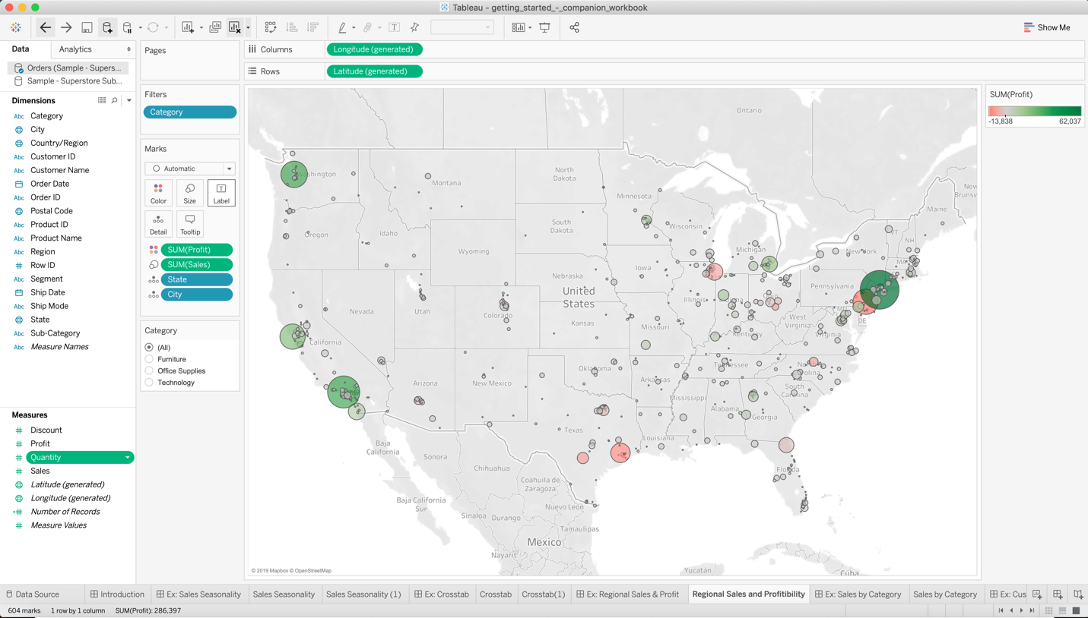

## Sales by Category:

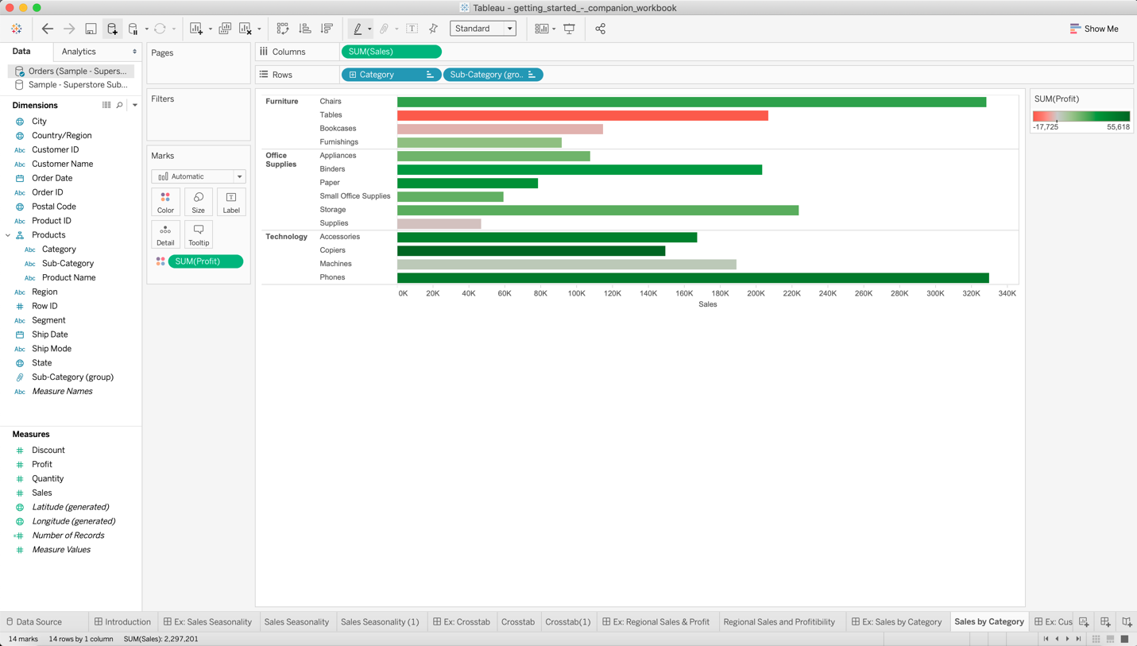

## Customer Breakdown:

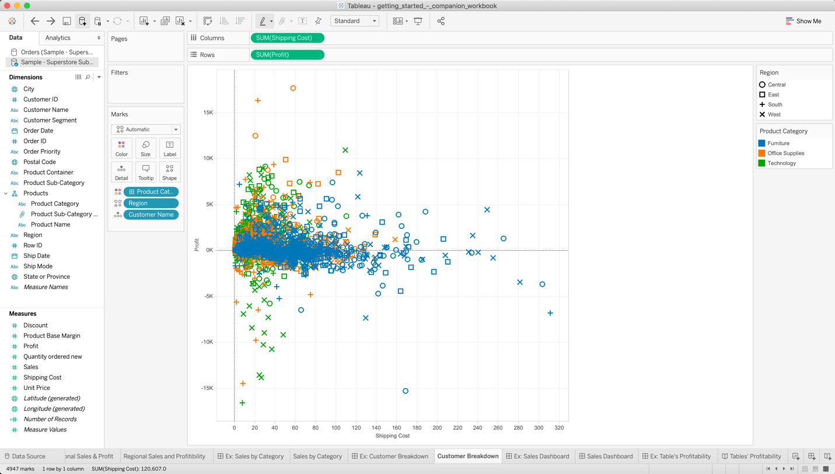

## 

## Sales Dashboard:

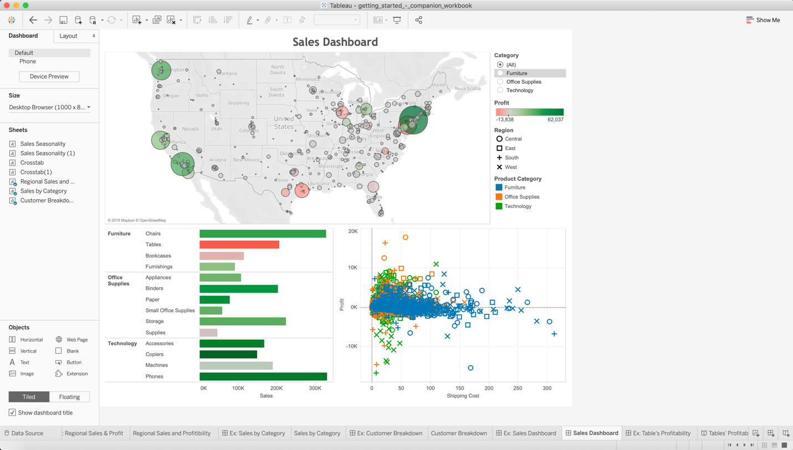

## Table’s Profitability:

Building a story with the help of the above visualizations created. Story Points lets you save snapshots of specific states of a visualization while retaining full interactivity.

